Language: C++

IDE: Sublime Text

Make sure all the files are in a common folder. The given picture is the sample output given. But it will run on any specified word. Please go to any file (file1-file7) and take any word excluding the stop words and it should be able to give the specified output(link). Should you want to change the number of samples, please change the value of **pageNumber** in my code.

The content of the input does not contain any punctuations and numbers except the comma and full stop that follow the sentence.

Sample output:

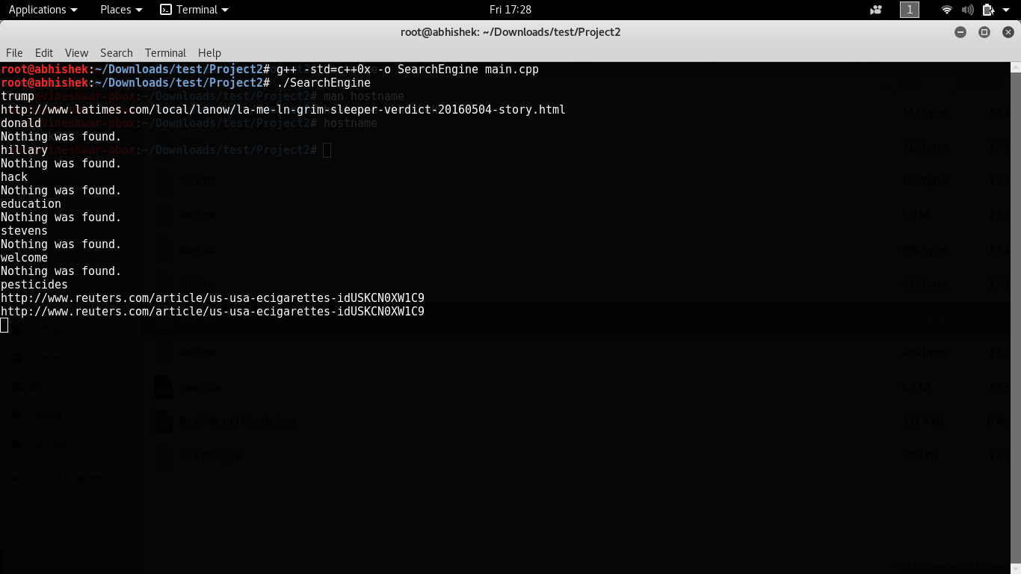

I have used Bash. But it should run on any Linux or Unix system or Linux Lab-Stevens. If you have mingw installed on Windows then it will work. Please compile using g++ -std=c++0x -o SearchEngine main.cpp.